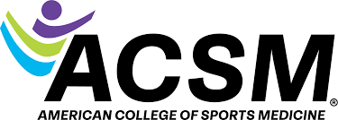
Mid-Atlantic
Chapter

MARC-ACSM

2026 Annual Meeting
EXPO and Graduate Fair

November 13th-14th, 2026
Sheraton Convention Center
Harrisburg, PA

Table of Contents

Welcome to MARC-ACSM………………………………..……3

University and Corporate Sponsorship Opportunities………...5

University Sponsorship Opportunities………………..………...6

University Sponsorship Comparisons.………………..………...7

Corporate Sponsorship Opportunities……………………..…...8

Corporate Sponsorship Comparisons.………………..………...9

WELCOME TO MARC-ACSM
The Mid-Atlantic Chapter of the American College of Sports Medicine (MARC-ACSM) is one of twelve regional chapters of ACSM. We are a diverse group of professionals and students committed to advancing sports medicine and exercise science. We serve 800 members in Delaware, Maryland, New Jersey, New York, Pennsylvania, West Virginia, and Washington, DC
The chapter aims to disseminate scientific information, serve as a platform for research, facilitate professional peer interaction, and promote career development.
The MARC-ACSM stands as a beacon of excellence in the realms of sports medicine and exercise science. As a dedicated nonprofit organization, our mission is to enhance the well-being, physical function, performance, and quality of life for individuals by integrating cutting-edge research with practical applications. Each year, our annual conference serves as a vibrant gathering of passionate individuals, including esteemed physicians, pioneering scientists, devoted educators, health professionals, and aspiring students. This two-day event is meticulously designed to immerse attendees in the latest innovations and emerging insights from the fields of sports medicine and exercise science.
Kicking off with an inspiring Keynote Address from a world-renowned scientist, the conference showcases a rich tapestry of sessions featuring both regional talent and nationally recognized experts who present their groundbreaking research findings. Among the highlights is our Clinical Track, explicitly tailored for primary care sports medicine physicians, orthopedic surgeons, physical therapists, and athletic trainers. This focused track empowers participants to deepen their understanding of evaluations, treatments, and therapies through an evidence-based lens.
Beyond the annual conference, MARC-ACSM is committed to nurturing our members' professional and academic pursuits, offering invaluable leadership training and mentoring opportunities that contribute to personal and professional growth. Join us in our mission to elevate the standards of sports medicine and exercise science while making a lasting impact on health and fitness.
MARC-ACSM Goals:
- Host dynamic annual meetings featuring engaging symposia, workshops, and impactful lectures to elevate educational and professional experiences.

- Create a vibrant forum for the exchange of cutting-edge information and groundbreaking research on all facets of Exercise Science and Sports Medicine, benefitting both professionals and the public.

- Enrich our community by sponsoring thought-provoking lectures and attracting renowned regional, national, and international researchers in Exercise Science and Sports Medicine to the Mid-Atlantic region.

- Champion and advance medical, educational, and scientific studies that explore the profound effects of sports and physical activity on the health of diverse populations, including both those who appear healthy and those living with known conditions.

- Foster collaboration and the sharing of knowledge among a network of dedicated professionals, including physicians, nutritionists, educators, scientists, exercise specialists, athletic trainers, physical therapists, and allied health professionals, all united by common goals and specialties.

- Inspire and engage graduate students by involving them in meaningful regional committee projects and responsibilities while passionately promoting their research endeavors within the ACSM community.

The 2026 Annual Meeting of The Mid-Atlantic Regional Chapter of the American College of Sports Medicine (MARC-ACSM) is November 13th and 14th at the Sheraton Convention Center in Harrisburg, PA. The EXPO and Graduate Fair will be held Friday, November 13th from 8:00 am to 7:00 pm, and Saturday, November 14th from 8:00 am to 11:30 am.
Registration for the EXPO and Graduate Fair will open June 8th, 2026.

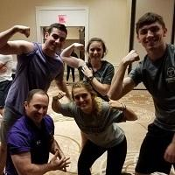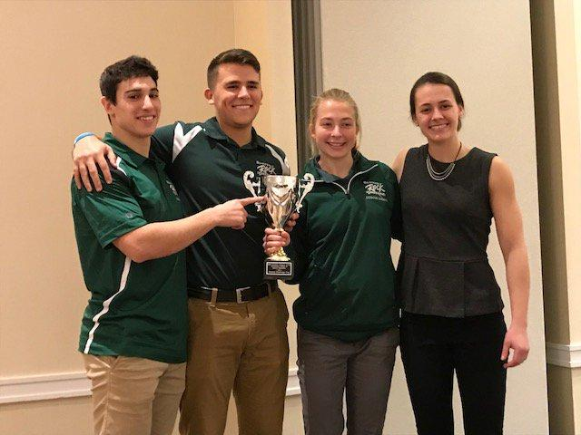

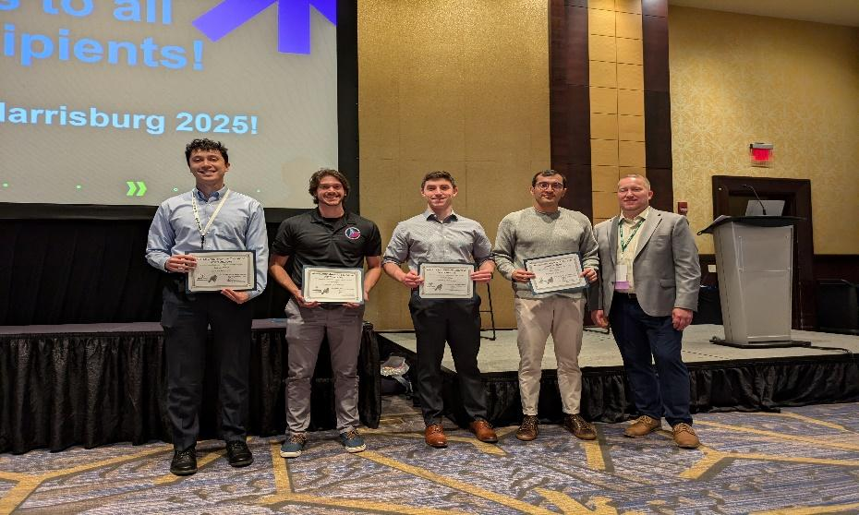
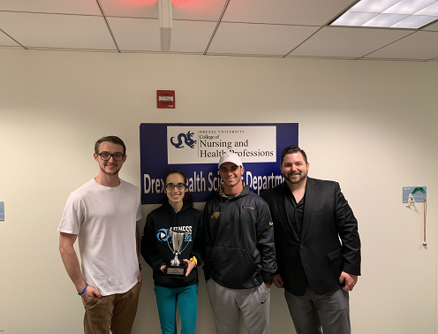

University and Corporate Sponsorship Opportunities
The Diamond, Platinum, Gold, Silver, and Bronze Packages present an exceptional opportunity for supporters to gain unparalleled visibility before and during our annual conference. Your brand will be prominently featured in key promotional materials, including the MARC-ACSM conference website, program guide, and event-related media. By aligning with us at this prestigious event, you'll stand alongside our premier supporters, ensuring your presence is felt throughout the conference. Please note that the number of opportunities for Diamond, Platinum, and Gold support is limited, so don’t miss your chance to make a lasting impact!

Diamond Keynote Sponsorship - $3,500 (Limited to 1)
- Keynote Address representation.

- Pre-meeting representation

- Logo is listed prominently in the meeting program.

- Logo is listed on the MARC-ACSM Website and recognized in the newsletters for one year.

- Logo will be placed on a single PowerPoint slide and included in the Keynote Address.

- Your university/company is recognized from the podium at the Keynote Address.

7. Premium exhibit space

Diamond College Bowl Sponsorship - $3,500 (Limited to 1)
1. College Bowl representation.

2. Pre-meeting representation

3. Logo is listed prominently in the meeting program.

4. Logo is listed on the MARC-ACSM Website and recognized in the newsletters for one year.

5. Logo will be placed on a single PowerPoint slide and included in the College Bowl.
.
6. Your university/company is recognized from the podium at the College Bowl.

7. Premium exhibit space

Diamond Clinical Sponsorship - $3,500 (Limited to 1)
- Pre-meeting representation

- Logo is listed prominently in the meeting program.

- Logo is listed on the MARC-ACSM Website and newsletter for one year.

- Logo will be placed on a single PowerPoint slide at all invited Clinical Track presentations, tutorials,
symposiums, and all free communication sessions.

- Your university/company is recognized from the podium at the Clinical Track events.

- Premium exhibit space
University Sponsorship Opportunities
Platinum Sponsor - $1,000 (Limited to 2)
- 1 booth with two seats in a prime location
- Sponsor session with promotional video
- Sponsor logo on all MARC-ACSM social media platforms’ main page throughout the year.
- Full-page advertisement on conference meeting program
- Logo on MARC-ACSM’s Chapter conference website for 2026

Gold Sponsor - $500 (Limited to 5)
1. 1 booth with two seats in a prime location
2. Promotional video at the beginning of a proposed session
3. Full-page advertisement on conference meeting program
4. Logo on MARC-ACSM’s conference website for 2026

Silver Sponsor -$400
1. 1 booth with two seats
2. Logo projected on a screen in a scrolling fashion at the beginning of a proposed session
3. Half-page advertisement on conference meeting program

Bronze Sponsor -$300
1. 1 unmanned booth
2. Quarter-page advertisement on conference meeting program

University Sponsorship Comparisons
Benefits | Platinum  $1,000 | Gold  $500 | Silver  $400 | Bronze  $300
Logo on newsletters and social media | 
Premium exhibitor space
Logo and link to sponsor’s website on MARC-ACSM website
Promotional video prior to session
Logo on screen prior to session
Logo in the conference program
Skirted table with two chairs
Unmanned booth

**Note that if your organization registers late/close to the conference, not all
benefits may be available.

Corporate Sponsorship Opportunities

Platinum Sponsor - $2,000 (2 total, one for College Bowl and one for Keynote)

- 1 booth with two seats in a prime location plus space to set up products.

- Promotional video or sponsorship announcement at the beginning of College Bowl or Keynote

- Sponsor logo on all MARC-ACSM social media platforms throughout the year.

- Full-page advertisement on conference meeting program Logo on MARC-ACSM’s conference website for 2026.

- Sponsorship will be applied to the Student Travel Award. The award will cover selected students' conference registration fees and logging costs.

Gold Sponsor - $1,000 (Limited to 2)

- 1 booth with two seats in a prime location.

- Promotional video at the beginning of an invited session or luncheon.

- Half-page advertisement on conference meeting program.

- Logo on MARC-ACSM’s conference Website for 2026.

Silver Sponsor - $500

- 1 booth with two seats

- Quarter-page advertisement on conference meeting program

Corporate Sponsorship Comparisons
Benefits | Platinum  $2,000 | Gold  $1,000 | Silver  $500
Logo on newsletters and social media
Premium exhibitor space
Logo and link to sponsor’s website on MARC-ACSM website
Promotional video prior to session
Logo on screen prior to session
Logo in the conference program
Skirted table with two chairs
**Note that if your organization registers late/close to the conference, not all
benefits may be available.

